**SSS-NN(c/e)-YY-R**

**SSS** – System, Sub-System

**NN** – Number

Starts at 01, odd numbers only, even numbers reserved for corresponding handed parts

**(c/e)** – suffix for car specific

**YY** – year design (eg. 22 refers to 2022 competition season)

**R** – revision, starts at A

**Note:** **Do not place a part description in the numerical name of the part!** See “Descriptions” below.

WR222C

WR222E

* 000 – RESEARCH AND DEVELOPMENT
* 100 – AERO & ERGO
* 200 – CHASSIS
  + 210 – SUSPENSION
  + 220 – ACTUATION
  + 230 – ANTIROLL
  + 240 – C CORNERS
  + 250 – BRAKES
  + 260 – PEDALS
  + 270 – STEERING
* 300 – C POWERTRAIN
* 400 – E DRIVETRAIN
* 500 – ACCUMULATOR
* 600 – E ELECTRONICS
* 700 – C ELECTRONICS
* 800 – PROPRIETARY HARDWARE
* 900 – JIGS & FIXTURESS

**Setting Part Descriptions:**

A part description can be added when saving a Solidworks part by clicking below the type box as shown:

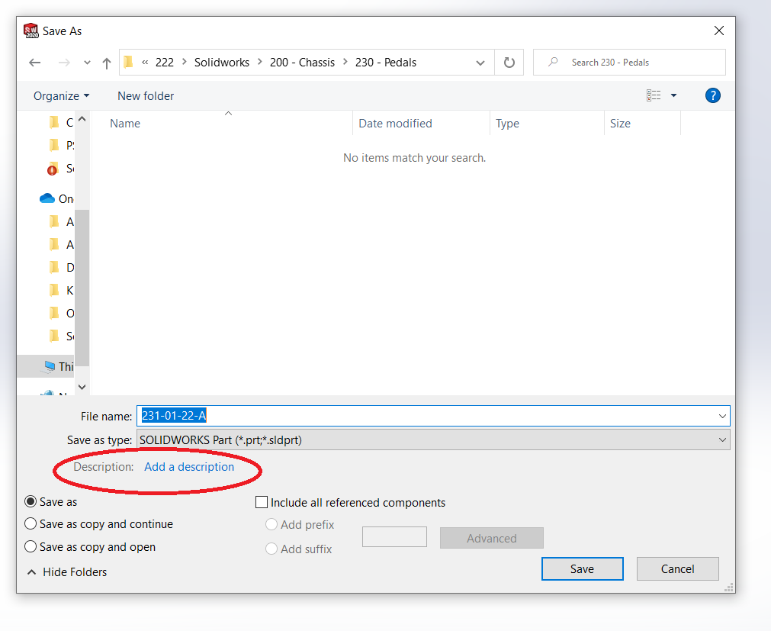

The part description can also be modified by right-clicking a file, selecting Properties, and then selecting the Details tab in the dialog box.

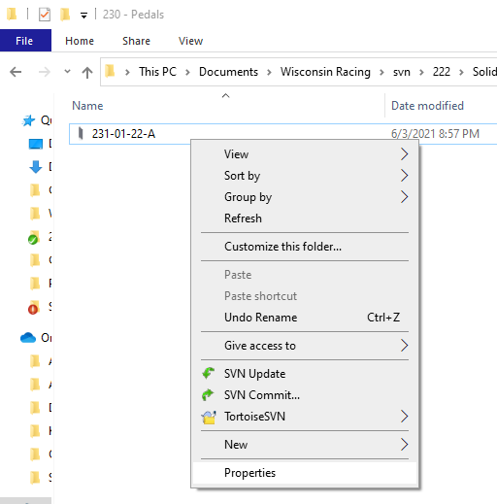 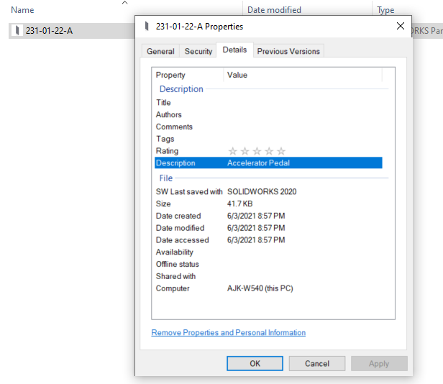

**Displaying Part Descriptions**

To display part descriptions for only one folder, follow only the instructions on the next page.

To display part descriptions for every subfolder in the Solidworks subversion directory, navigate to the top-level folder and select Properties for the Solidworks folder. In the dialog box, select Customize:

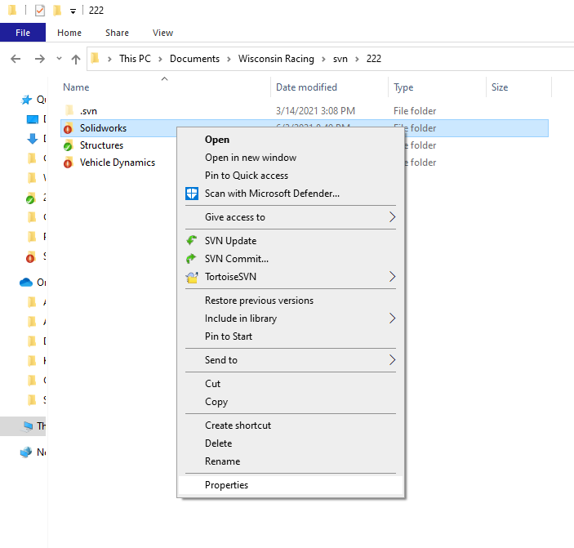 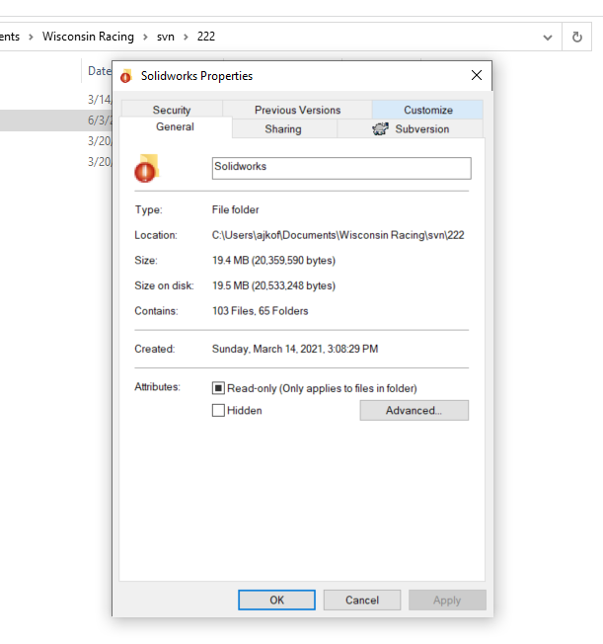

Choose to optimize the folder for General Items. All this means is that certain properties will be preset to display in the header. For us, this will be used for Solidworks parts and will show part descriptions:

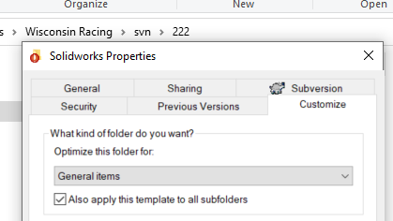

Make sure to check the box to apply the template to all subfolders, so the entire directory will be covered in one shot.

To display the part descriptions, right-click on a header item (Name, Type, etc.) and then click More:

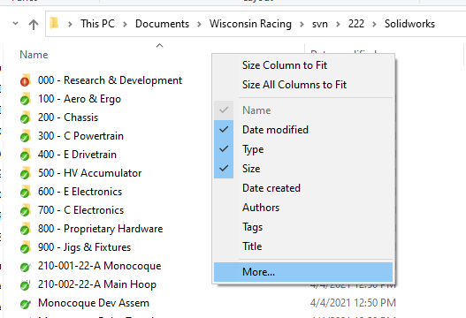

A dialog box will open with a long list of potential properties. Scroll down to Description. Note that there are two Description properties. Only the first one will work, so select it.

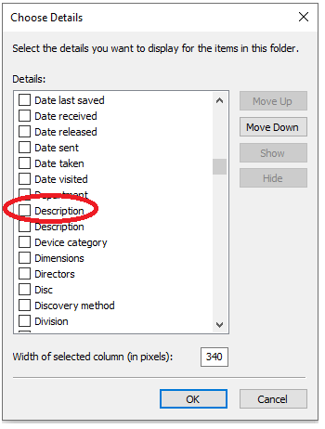

A Description property will then appear in the header.

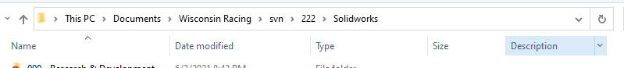

Optional: Drag the Description header to the position of your choice. Note that the configuration will be the same for all folders in the directory.

Select File, then “Change folder and search options”, and then the View tab in the dialog box. Select “Apply to Folders” to apply the template to all folders optimized for General Items.

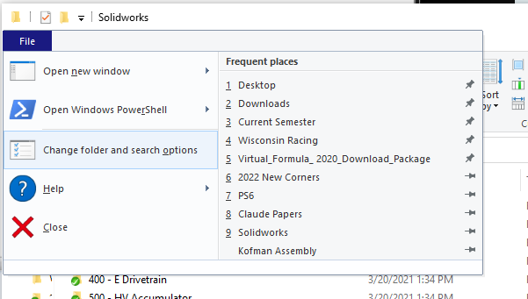 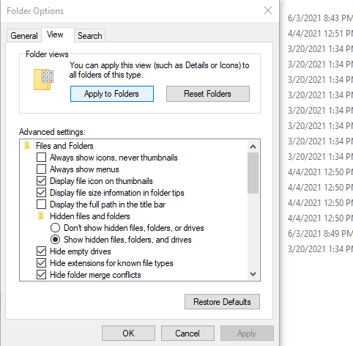

Click Yes on the dialog to confirm the change.

